**Use case 5**

**Domain: Automotive**

**Case- RADAR sensors for Adaptive Cruise control using AI for Human detection**

**Context:**

Adaptive Cruise Control (ACC) is a common feature in modern vehicles that helps maintain a safe following distance between your car and the vehicle in front of you. It uses sensors to detect the distance and relative speed of the car ahead and adjusts your vehicle's speed accordingly. The traditional ACC systems rely on predefined rule-based algorithms, but AI is now being employed to make ACC more intelligent and responsive.

**Data Collection**

**Radar Sensors**: The radar sensor emits a short burst of radio waves.

The radio waves travel to the target object and are reflected back to the radar sensor.

The time it takes for the radio waves to travel to the target and back is used to calculate the distance to the target.

The angle at which the radio waves are reflected is used to calculate the direction of the target.

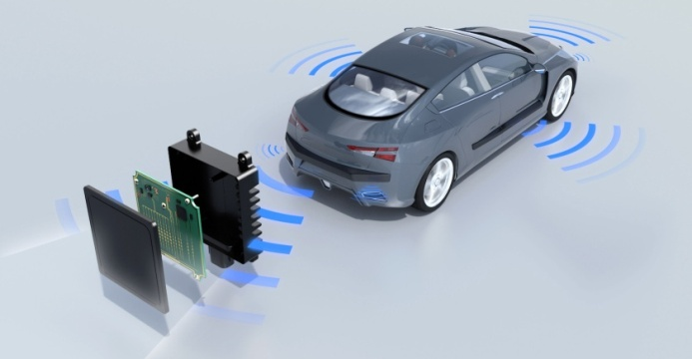

**Data Processing**

The radar data is then processed by the AI. The AI uses a variety of techniques to analyze the radar data, such as:

**Feature extraction**: The radar sensor can extract features from the reflected wave, such as the amplitude, shape, and duration of the wave. These features can be used to identify different objects, including humans.

**Machine learning**: Machine learning algorithms can be used to train the radar sensor to identify humans. The algorithms are trained on a dataset of radar data that includes both humans and other objects. The algorithms learn to identify the features that are characteristic of humans and use these features to detect humans in new radar data.

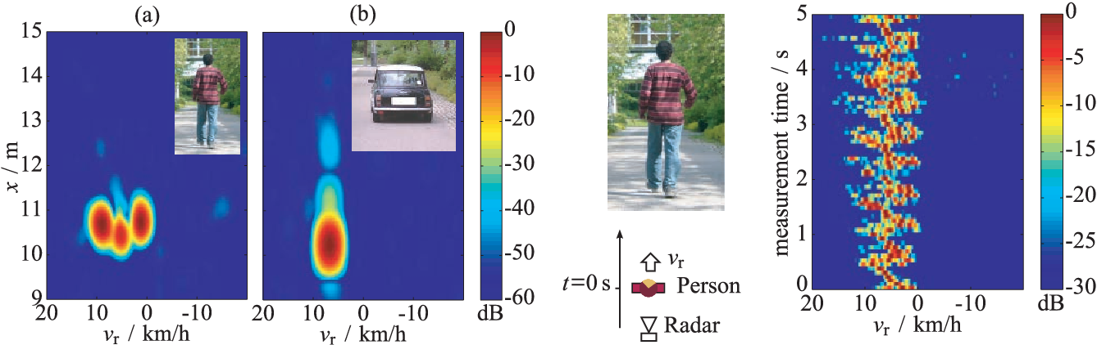

**The View-of-Delft (VoD) dataset** is a recently published 4D radar dataset especially focused on the detection of VRUs (vulnerable road user). The sensor suite includes a ZF FRGen 21 4D radar, a 64-beam LiDAR, and a stereo camera. It provides 8693 annotated frames with 3D bounding boxes and tracking IDs. Each object is also annotated with two levels of occlusion and four types of activity attributes (stopped, moving, parked, pushed, sitting). It provides fine-grained annotations of vehicles, trucks, and 10 classes of VRUs. Different classes are equally distributed (21.6% pedestrians, 8.8% cyclists, and 21.9% cars)

[](https://intelligent-vehicles.org/wp-content/uploads/2022/02/sensors.gif) 

**Conclusion**

The use of AI in radar sensors is making it possible for cars to detect humans more accurately and reliably. This is important for safety, as it can help to prevent accidents involving pedestrians and cyclists.